First meeting:
Determine the project steps:
1. Interface design (including layout, design buttons, beautification, etc.)
2. Program design (mainly the background running architecture and the interaction with the database)
3. Management (document management, project iteration, etc.)
Division of labor according to group members:
1. Chen Kaiwen and Tang weiheng tried prototype design
2. Wang shuai, Lin Xiao and Zhang Bowen wrote user stories and flow charts
3. Liu Kang and Shan Chenfeng are responsible for the background code

Second meeting
It was decided that Chen Kaiwen and Tang weiheng would use the right tools for the prototype design
Wang shuai, Lin Xiao and Zhang Bowen to improve the flow style, and find relevant web design information
Liu Kang and Shan Chenfeng continued to be responsible for the code

Third meeting
1. Improve the design of APP prototype (Chen Kaiwen, Tang weiheng)
2. Design web layout (Chen, Tang)
3. Database design (Zhang Bowen, Shan Chenfeng)
4. Modify flow chart (Lin Xiao)
5. Make PPT (Wang Shuai)
6. Complete login and make code explanation (Liu Kang)

The division of roles for Belbin is the result of the team members' consultation during the winter vacation.To some extent, it affects the conditions under which team members select work tasks.
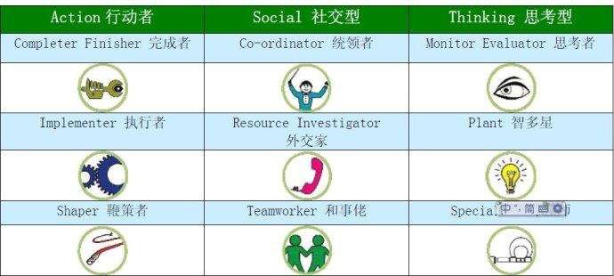
Wang Shuai —— Plant
Tang Weiheng —— Resource Investigator
Chen Kaiwen —— Teamworker
Lin Xiao —— Monitor evaluator
Zhang Bowen —— Completer
Liu Kang —— Sharper
Shan Chenfeng —— Company Worker

